**Install and Configure git on Linux and Configure to Talend TAC & Studio**

1. **Install httpd**

sudo yum update -y

sudo yum install httpd -y

sudo systemctl start httpd

sudo systemctl enable httpd

sudo systemctl status httpd

**2.Install Git and gitweb**

sudo yum install git gitweb –y

git config --global user.name "root"

git config --global user.email “[omkar.patil@thinkartha.com](mailto:omkar.patil@thinkartha.com)”

git config –list

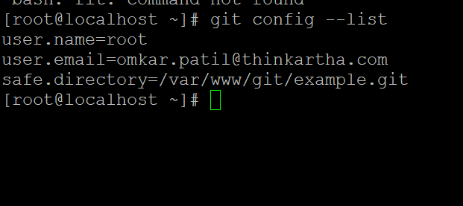

3. **Configure gitweb**

sudo vi /etc/gitweb.conf

# Path to your repositories

$projectroot = "/var/www/git/example.git";

$projects_list = "/var/www/git";

$git_bin = "/usr/bin/git";

$gitweb_url = "http://192.168.5.213/gitweb";

$export_ok = "true";

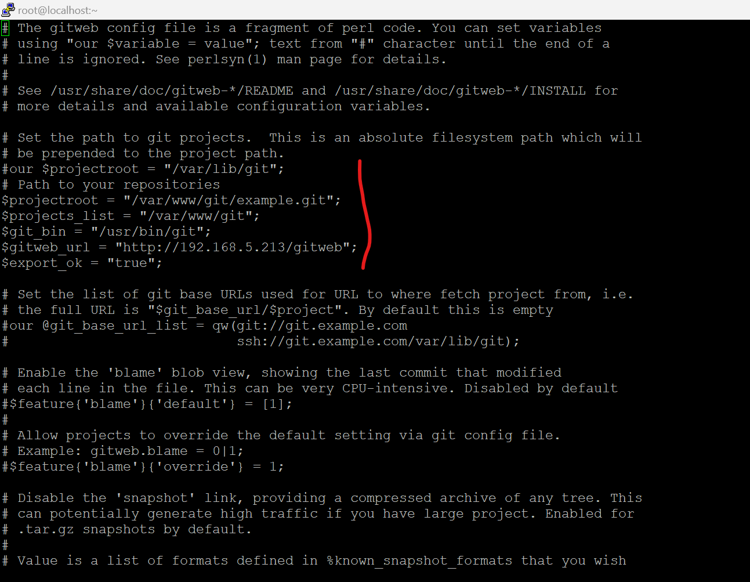

**4 .Set Up Apache to Serve gitweb**

sudo vi /etc/httpd/conf.d/gitweb.conf

Alias /git /var/www/git

<Directory /var/www/git>

Options +ExecCGI

AddHandler cgi-script .cgi

DirectoryIndex gitweb.cgi

</Directory>

Alias /gitweb "/usr/share/gitweb"

<Directory "/usr/share/gitweb">

Options +ExecCGI

AddHandler cgi-script .cgi

Require all granted

</Directory>

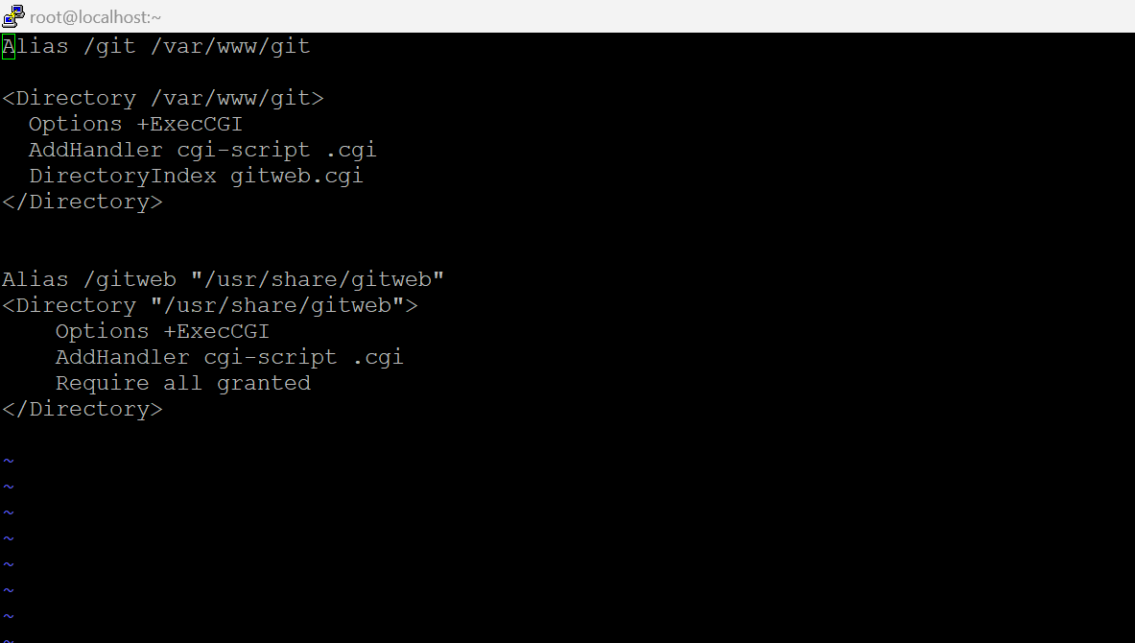

sudo systemctl restart httpd

**5 .Create a Repository**

sudo mkdir -p /var/www/git

sudo chown -R apache:apache /var/www/git

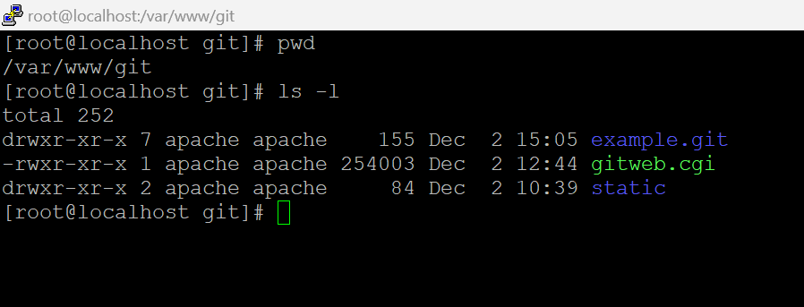

cd /var/www/git

sudo git init --bare example.git

sudo chown -R apache:apache example.git

**6. Change the httpd.conf parameter**

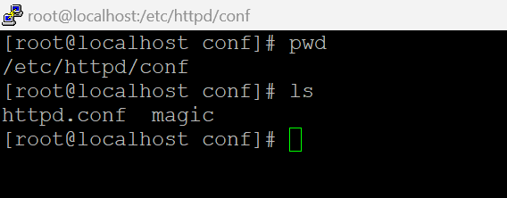

Vi httpd.conf

User apache

Group apache

ServerName 192.168.5.213:80

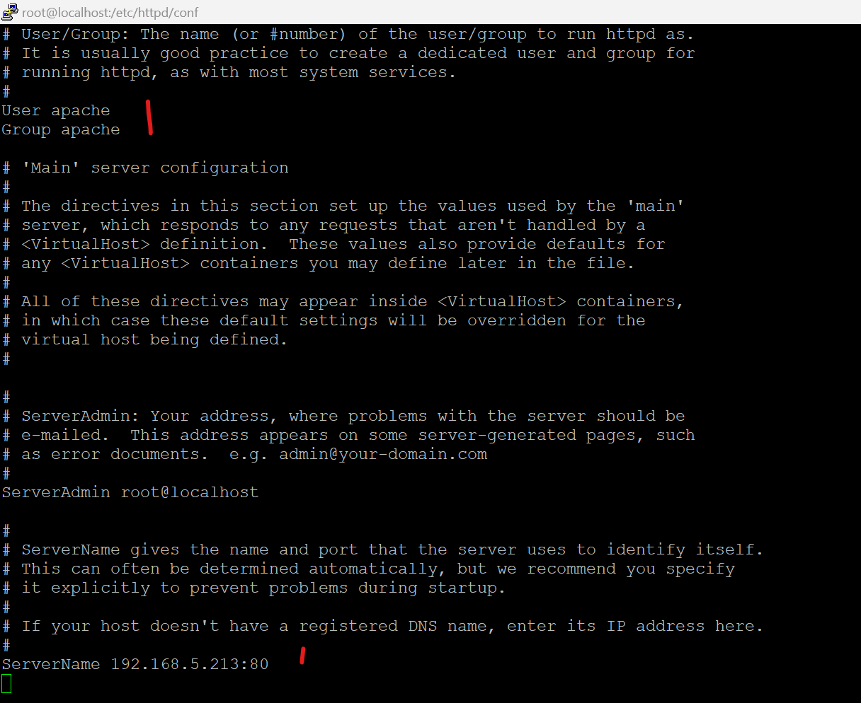

**7.Change in etc configurations file**

cd /etc/httpd/conf.d

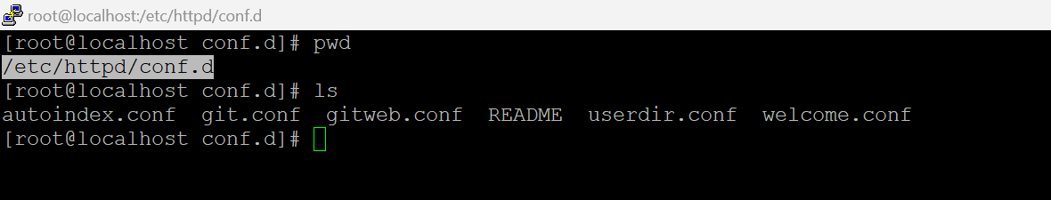

vi git.conf

ScriptAlias /git/ /usr/libexec/git-core/git-http-backend/

<Location "/git">

AuthType None

Require all granted

SetEnv GIT_PROJECT_ROOT /var/www/git

SetEnv GIT_HTTP_EXPORT_ALL

SetEnv REMOTE_USER=$REDIRECT_REMOTE_USER

</Location>

<Directory "/var/www/git">

Options +ExecCGI

Require all granted

</Directory>

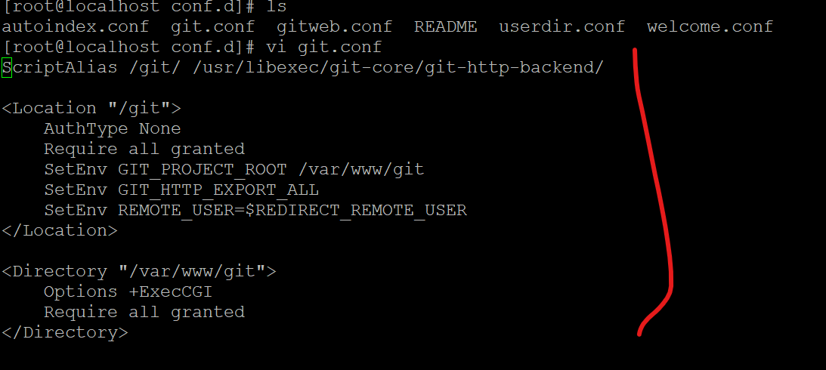

vi gitweb.conf

Alias /git /var/www/git

<Directory /var/www/git>

Options +ExecCGI

AddHandler cgi-script .cgi

DirectoryIndex gitweb.cgi

</Directory>

Alias /gitweb "/usr/share/gitweb"

<Directory "/usr/share/gitweb">

Options +ExecCGI

AddHandler cgi-script .cgi

Require all granted

</Directory>

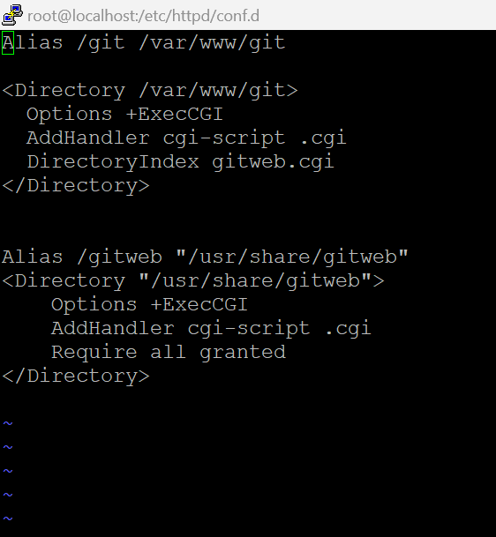

**8. Check the repository branch updates with list**

List the files in the branch:

cd /var/www/git/example.git

git ls-tree --name-only master

git ls-tree -r master --name-only

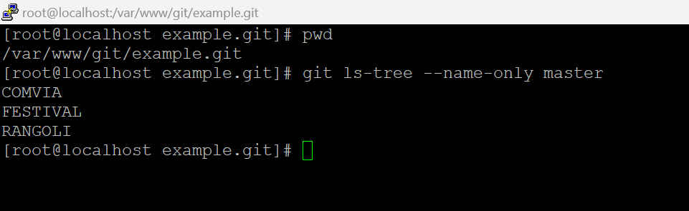

**9. Clone the repo from any another location**

git clone http://192.168.5.213/ git/example.git

cd example

echo "Hello, Gitweb!" > index.html

git add index.html

git commit -m "Initial commit"

git push origin main

**10. Add the Directory as a Safe Directory**

git config --global --add safe.directory /var/www/git/example.git

**11.Connect to TAC**

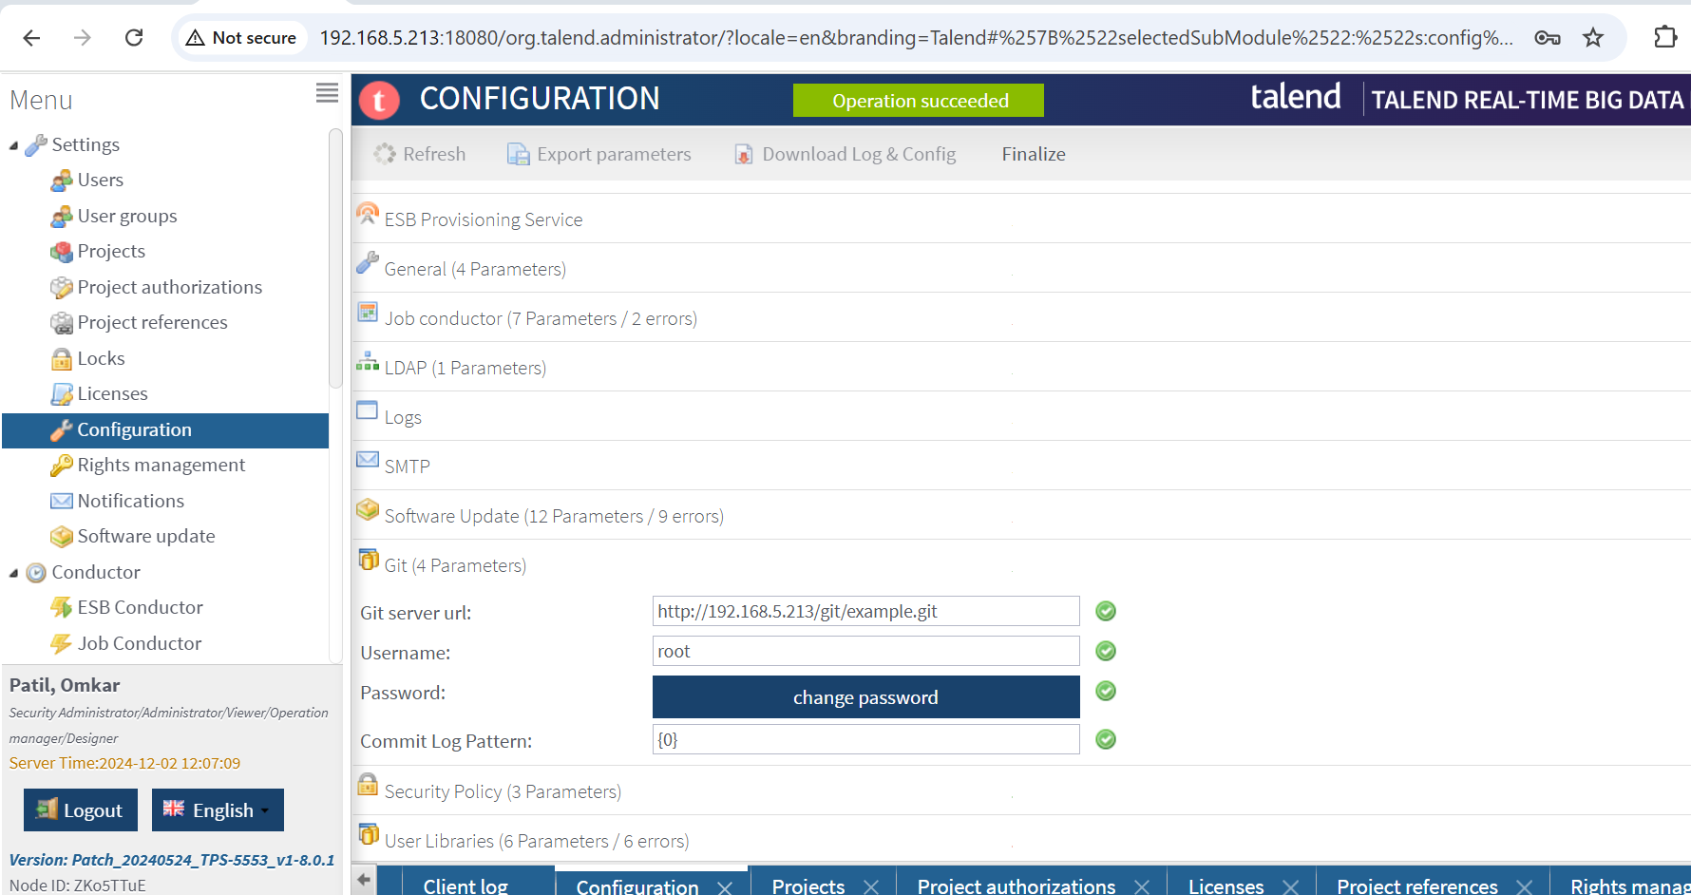

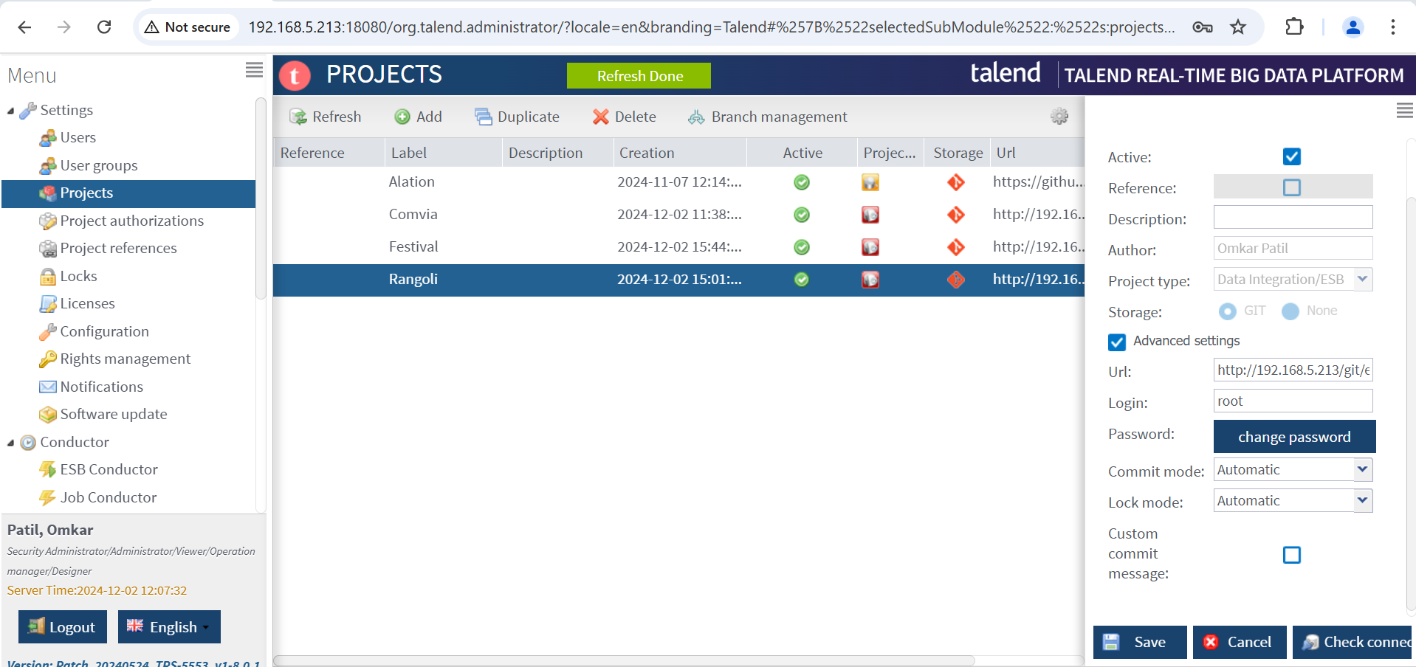

**12.Connect to studio**

